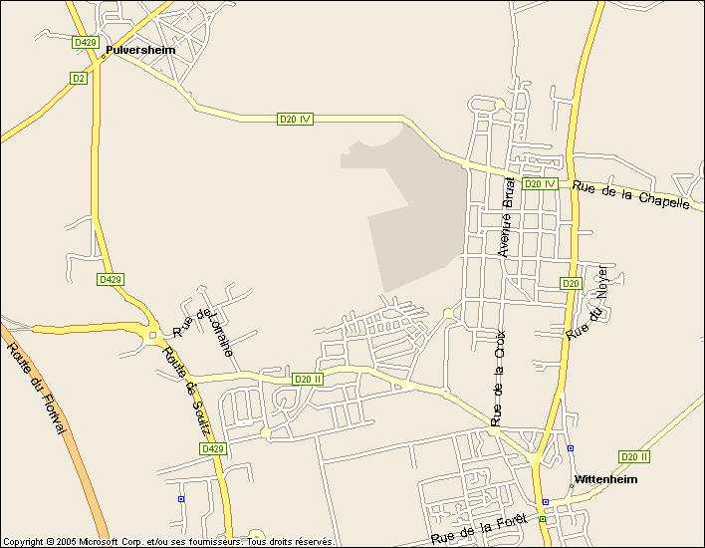
Auto-casse
SANNER
EDUCANI

